Test Project

Web Technologies

Speed Test

Submitted by:

Thomas Seng Hin Mak WS

Marcelo Strehl BR

Seunglyul Ryu KR

Abraham Quesada CR

Ilya Belyakov RU

Chorng-Shiuh Koong TW

Manuel Schaffner CH

Siew Hwa Kang SG

Zoltan Sisak HU

# Contents

1. Contents 3
2. Introduction 5
3. Part A: Website Design 6
   1. A1: Blur Picture Image (Easy) 6
   2. A2: Transparent Background (Easy) 6
   3. A3: Pattern (Easy) 6
   4. A4: Loading GIF (Normal) 6
   5. A5: Walking Gif (Normal) 6
   6. A6: UI-kit (Difficult) 6
   7. A7: Messenger (Difficult) 6
4. Part B: Layout 7
   1. B1: HTML tags (Easy) 7
   2. B2: CSS Grid (Normal) 7
   3. B3 Loading Screen (Normal) 8
   4. B4 Toggle (Normal) 8
   5. B5 Yellow Square (Easy) 8
   6. B6 Triangle (Easy) 8
   7. B7 Grayscale image (Easy) 8
   8. B8 Jumper Ball (Easy) 8
   9. B9: HTML/CSS – Contact Form (Normal) 9
   10. B10: Border Radius & Box Shadow (Easy) 9
   11. B11: Race track (Normal) 9
   12. B12: Video player interface (Layout) 9
   13. B13: Gradient animation (Easy) 9
   14. B14: Modern layout (Easy) 9
   15. B15: Seven segment digital Timer (Difficult) 10
5. Part C: Front-End Development 11
   1. C1: Cube Rotation (Difficult) 11
   2. C2: Loading Animation (Normal) 11
   3. C3: Drawing Canvas (Normal) 12
   4. C4: RGB Slider (Normal) 12
   5. C5: JS – Calculation (Easy) 13
   6. C6: JS - ASCII-Art (Difficult) 13
   7. C7: HTML/CSS, JS – Clock (Difficult) 13
   8. C8: HTML/CSS, JS - Tag-Control (Normal) 13
   9. C9: List of expenses: (Easy) 13
   10. C10: Simple Image Filter (Difficult) 14
   11. C11: Canvas Animation (Easy) 15
   12. C12: JS Arithmetic (Difficult) 16
   13. C13: JS Draggable (Normal) 16
   14. C14: Keyboard (Difficult) 16
   15. C15: Parallax (Normal) 17
   16. C16: Smiley (Normal) 17
   17. C17: Transition (Normal) 17
   18. C19: Chart from data (Difficult) 18
   19. C24: Array Integers (Easy) 19
   20. C25: Following cursor (Easy) 19
   21. C26: Circles (Normal) 19
   22. C27: Linear gradient (Normal) 20
6. Part D: Back-End Development 21
   1. D1: PHP Calendar (Difficult) 21
   2. D2: Plugin works (Easy) 21
   3. D3: PHP Array (Easy) 21
   4. D4: PHP Verification captcha (Difficult) 22
   5. D5: Watermark (Easy) 22
   6. D6: Predominant colors (Easy) 22
   7. D8: File manager (Normal) 22
   8. D10 Image Cropper (Normal) 22
   9. D11: A Pagination Code (Nromal) 23
   10. D12: XML2JSON Converter (Difficult) 24
   11. D13: Remove duplicates (Easy) 24
7. Part E: Content Management Systems 25
   1. E1: Animated Social Button Plugin (Normal) 25
   2. E2: Dropdown menu plugin (Difficult) 26
   3. E3: CountDown Kazan WorldSkills plugin (Normal) 26
   4. E4: Plugin works (Easy) 27
   5. E5: Gallery Upload (Normal) 27
   6. E6: Custom Area (Easy) 27
   7. E7: Widget (Easy) 27
   8. E8: Technical works (Normal) 27
   9. E9: Color theme (Normal) 27
   10. E10: Installing Wordpress (Easy) 27
8. Instructions to the Competitor 28
9. Marking Scheme 28

# Introduction

In this module, you are given 3 hours to complete mini tasks. There are 5 parts of mini tasks, they are design, layout, front-end development, back-end development and content management system.

You do not need to do all of the mini tasks. You will received instruction on which tasks that is required during competition.

# Part A: Website Design

## A1: Blur Picture Image (Easy)

Given a picture image, please use graphical software to make this on greyscale, put a blur effect, and save as a1.jpg.

## A2: Transparent Background (Easy)

Given an image on format jpg. Please use graphical software to turn the background into transparent, and save as a2.png.

## A3: Pattern (Easy)

Make a background image with any line pattern that repeat every 100x100 pixels, and save with 1920x1080 px as result.jpg.

## A4: Loading GIF (Normal)

Create a GIF animation with a word “Loading” that appears on the left edge of image and moves outside of the right edge of image. The animation should be within 3 seconds to complete.

## A5: Walking Gif (Normal)

Create a GIF animation from the given walk.gif file, so that the character moves in from the left edge of image and moves right and moves out of the right edge of screen.

## A6: UI-kit (Difficult)

Create a UI-kit of the following elements: text box, button, drop-down list, checkbox, radio button, label with checkbox, label with radio button, drop-down calendar input, range, progress bar.

## A7: Messenger (Difficult)

Draw 2 screen mockups for a messenger app with size 360x640.

1 screen - a list of dialogs (avatar, full name, message preview).

2 screen - chat with the user (avatar, full name, menu (three points), messages, text field, send button)

All elements should exist.

# Part B: Layout

## B1: HTML tags (Easy)

A customer wants you to make his writings into HTML so that it displays well in web browser. He has written the text. Your job is to use HTML to define the content for web browser to properly display it. Please consider semantic tags and accessibility.

## B2: CSS Grid (Normal)

Please implement the following layout in CSS grid.

## B3 Loading Screen (Normal)

Create an animated loader using only HTML and CSS same as video.mp4. The loader animation should be looped. 4 different colors (#19A68C, #F63D3A, #FDA543, #193B48) should be used.

Screen shots:

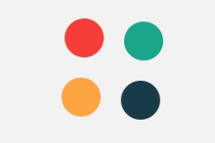  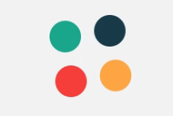 

## B4 Toggle (Normal)

To create an IOS Toggle switch using HTML and CSS only. View video for animation details.

|  |  |
| --- | --- |
|  |  |

## B5 Yellow Square (Easy)

Make an animation that starts with a big yellow square, and this square turns a small red circle, the animation needs to be centered on the view and the animation needs to loop;

## B6 Triangle (Easy)

Make a blue equilater triangle on the center of the view, and animate this to transform a yellow square. the animation needs to be fluid and loop infinite;

## B7 Grayscale image (Easy)

- Turn the image on grayscale, and when hover the mouse, the image need to be color with a transition;

## B8 Jumper Ball (Easy)

- Make a loop animation of a jumper ball respecting all states from a animation (only css);

## B9: HTML/CSS – Contact Form (Normal)

An HTML and CSS implementation of a not yet finished form are given.

Modify the CSS and HTML so that the form looks as depicted in the screenshot in the media files.   
It’s responsive behaviour should follow the screencast in the media files.

The use of JavaScript is NOT allowed.

## B10: Border Radius & Box Shadow (Easy)

Create a page that contains a 400px rectangle in the middle.

Inside the rectangle there is a settings panel with inputs, where you can setup the rectangle's Border radius, and box shadow properties. The rectangle’s css updates on input changes.

## B11: Race track (Normal)

By using HTML and CSS, create a race track animation in the form of “8” (vertically or horizontally), along which the car will endlessly animated.

## B12: Video player interface (Layout)

Create video player interface: search form, browse screen, action buttons (play, mute, and volume), progress slider, playlist (one item from playlist must be active), information about the video (title, description, number of views), comments (not less than 5) (and 1 attached comment).

## B13: Gradient animation (Easy)

By using HTML and CSS, create a gradient shift animation on the page. The gradient may move into any direction.

## B14: Modern layout (Easy)

Your task is to create the following layout, the posts’ width is ⅓ of the container’s on desktop screen size (>=1440px) and full width below this.

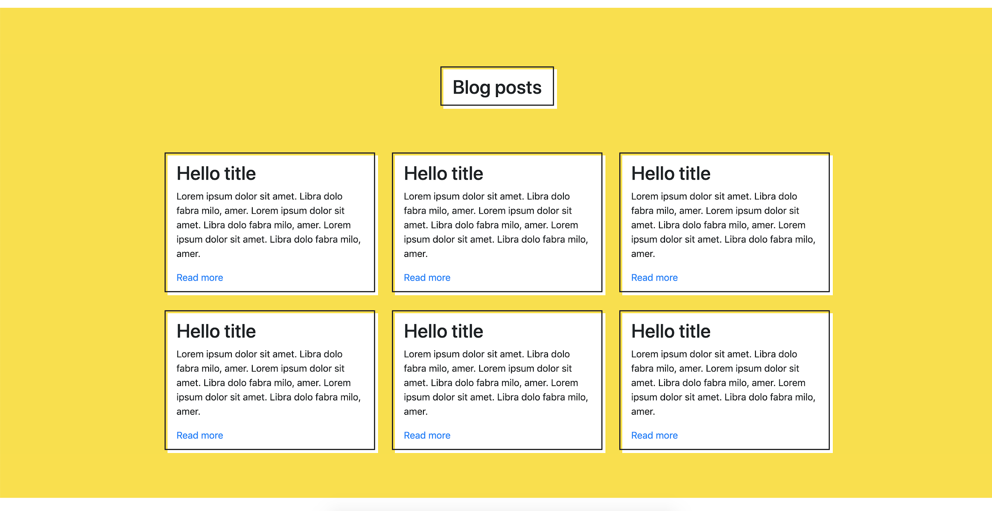

## B15: Seven segment digital Timer (Difficult)

Create a 7 segment digital timer, time format is: 3 digit of seconds passed, and centiseconds following it. It’s max value is: “999:59”. “Start timer“ button starts, “Stop timer” button stops, “Reset timer” button stops and resets to 0 the timer.

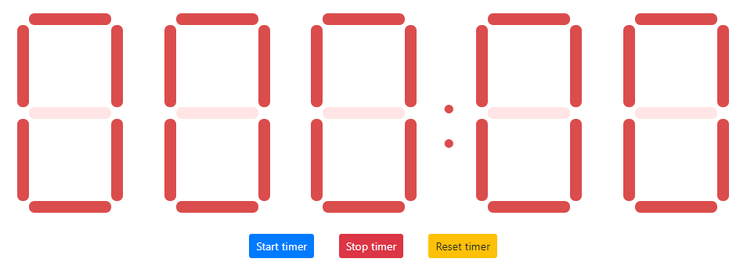

# Part C: Front-End Development

## C1: Cube Rotation (Difficult)

We want to create the following cube rotation effect.

1. You should create two cubes using the index.html and the cubes shuld be rotated same as video.mp4.

2. Left cube should be rotated left to right.

3. Right cube should be rotated up to down.

4. color codes

- front - #fa5252

- back - #f76707

- right - #12b886

- left - #4c6ef5

- top - #fab005

- bottom - #7950f2

5. You can only use style.css for the Cube Animation, JavaScript is not allowed.

## C2: Loading Animation (Normal)

We want to create the following CSS loading animation.



## C3: Drawing Canvas (Normal)

Please try to use canvas to build a drawing pad with the following features:

* Basic drawing with mouse down and move
* 3 color switching

## C4: RGB Slider (Normal)

Please implement an RGB slider as following. There are 3 sliders for adjusting values of red, green and blue.

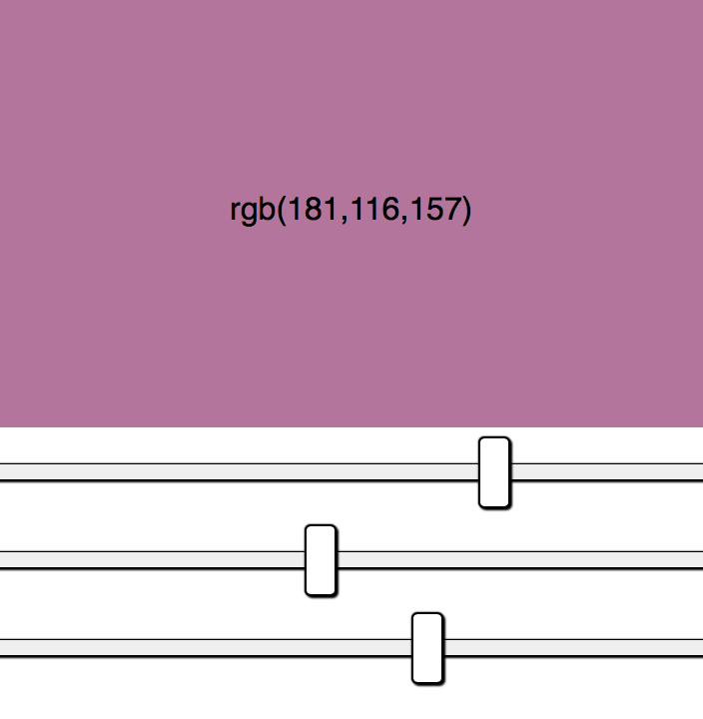

## C5: JS – Calculation (Easy)

Implement the function that calculate the sum of the squares of the odd numbers in a given array.

## C6: JS - ASCII-Art (Difficult)

You should implement the two methods for transforming the ASCII-input (an image made of standard characters) as described in file “ascii-art-editor.js” (rotate and mirror).

You can check the functionality in index.html – it will execute tests (call your functions with different input and test the output) and show its results.

## C7: HTML/CSS, JS – Clock (Difficult)

You have to implement a clock showing the current local system time.

The background should look as depicted in the media file “full-clock-fancy.png” containing clock border and ticks for hour and minute. Also the clock hands should look as depicted in the image. Seconds clock hand is updated every second, minutes clock hand is updated every minute, hour clock hand is updated every minute.

The image “full-clock-fancy.png“ can be used as you wish.

## C8: HTML/CSS, JS - Tag-Control (Normal)

You have to implement a Tag-UI-Control as shown in the animated GIF in the media-files.

Using the control, it should be possible to select tags from taglist.json, add new ones or remove selected tags. Typing should filter the availabe tags and – if none available – add the text as new tag.

## C9: List of expenses: (Easy)

**a**. Create a form with two fields called: **Spending name** and **Cost**

and an **add** button.

**b**. Using javaScript, perform the following functions:

1. Get the values of the fields.
2. Validate the entry of the data, if the fields are empty, print the message "There was an error", otherwise print "Correct".
3. Remove the expanded message and the data entered in the form after 3 seconds.
4. The data after being entered, must be shown in an ordered list using the HTML tags.

**\*** No resources are provided.

## C10: Simple Image Filter (Difficult)

For this speed Project you must create a function that allows you to add a filter in a certain image using canvas. This speed Project is divided into two parts.

Part 1

● Develop the following design:

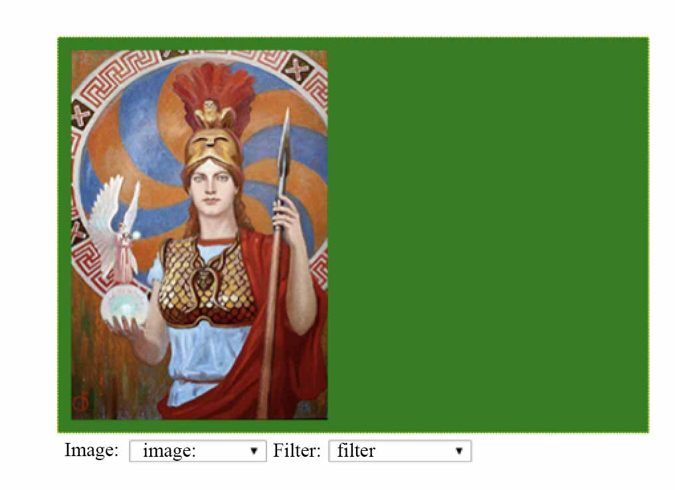

● The size of the canvas should be 460 pixels wide and 320 pixels high.

● Create a drop-down list, with the image options: Athena.jpg, theKiss.jpg, young-pearl.jpg and mona-lisa.jpg. There must be a first option called image.

● Load the images on the canvas depending on the option chosen in the drop-down list.

● The image of athena.jpg is loaded by default.

Part 2

● Create a drop-down list, called filter with the options: Darken and Lighten. There must be a first option called filter.

● When choosing a specific image in the dropdown list and applying a filter, the result should appear on the right side of the canvas according to the chosen option.

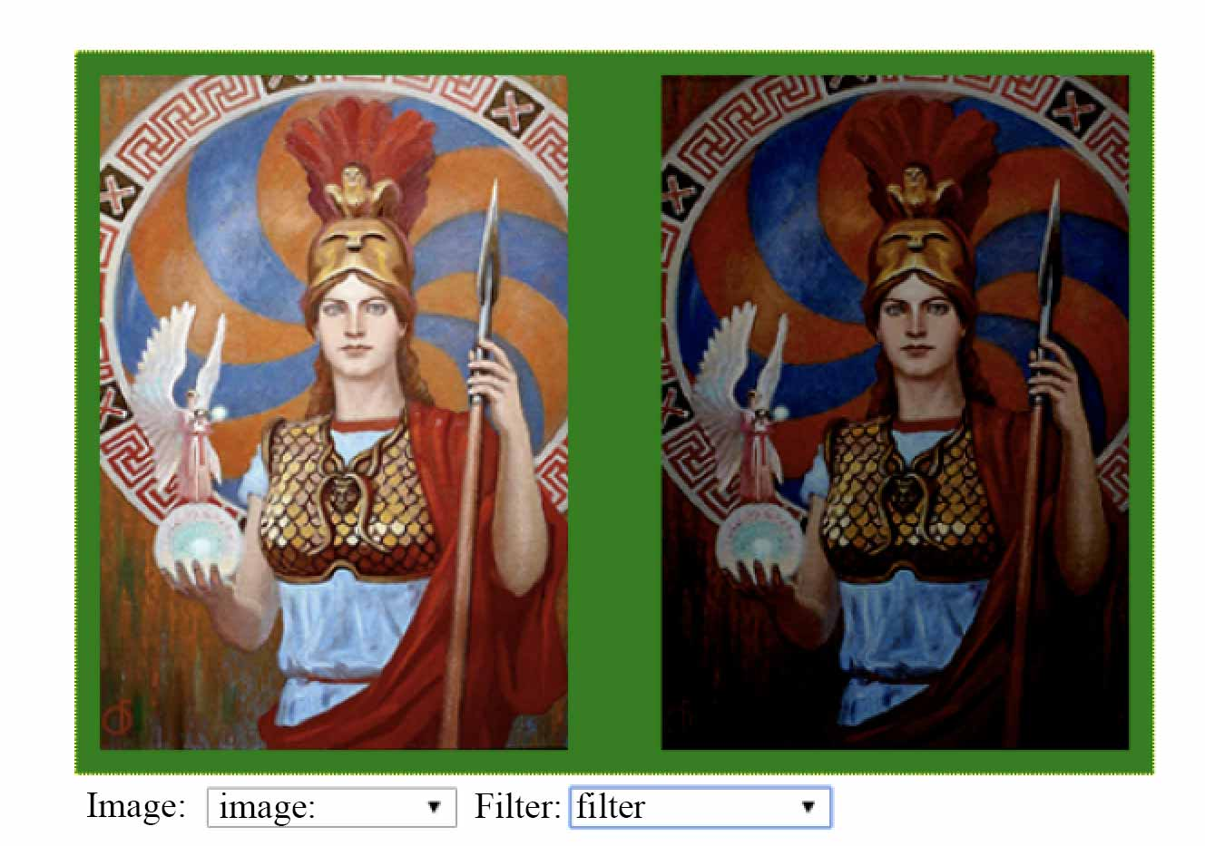

## C11: Canvas Animation (Easy)

Draw a circular figure in a container of 320px height and 400px width using canvas. When the browser window reloads, the circular object must move from left to right continuously.





## C12: JS Arithmetic (Difficult)

Please create an arithmetic function, that when you enter a string of expression, it returns the calculated result. This function should include the following operators, listed by precedence:

a. Parentheses: ()

b. Minus sign: -

c. Exponentiation: ^

d. Multiplication, division, modulus: * / %

e. Addition, subtraction: + -

Example 1:

The function input: 1+2*3

The function output: 7

Example 2:

The function input: 3^2%5

The function output: 4

Example 3:

The function input: (-1-2)^3/9

The function output: -3

## C13: JS Draggable (Normal)

Please implement Draggable function by using provided script.js, to make the parameter element draggable. Please see the provided video named video.mp4 to find draggable effect.

## C14: Keyboard (Difficult)

Create a text area where the text will be typed and under it a virtual keyboard on which keystrokes will be highlighted, including holding shift and stuff. Also with the keys on the virtual keyboard, you can type text by clicking on them. Shift is turned on and off by clicking on it, while the remaining keys enter their character in the text area.

## C15: Parallax (Normal)

Adjust the background parallax depending on the position of the mouse cursor (the closer the objects are to the user, the faster they move).

## C16: Smiley (Normal)

Create a big smiley face on the center of the page. It is 400px wide, and rectangular. Below the smiley, there are 3 buttons with texts: “:)”, “:|”, and” :(“. By clicking the buttons the smiley face changes to that state with a 0.5s animation. By default the smiley is in “:|” state. The states have these designs:



## C17: Transition (Normal)

You are given a picture that you need to cut into N cards and each card should disappear animated. X is 5 and Y is 3.

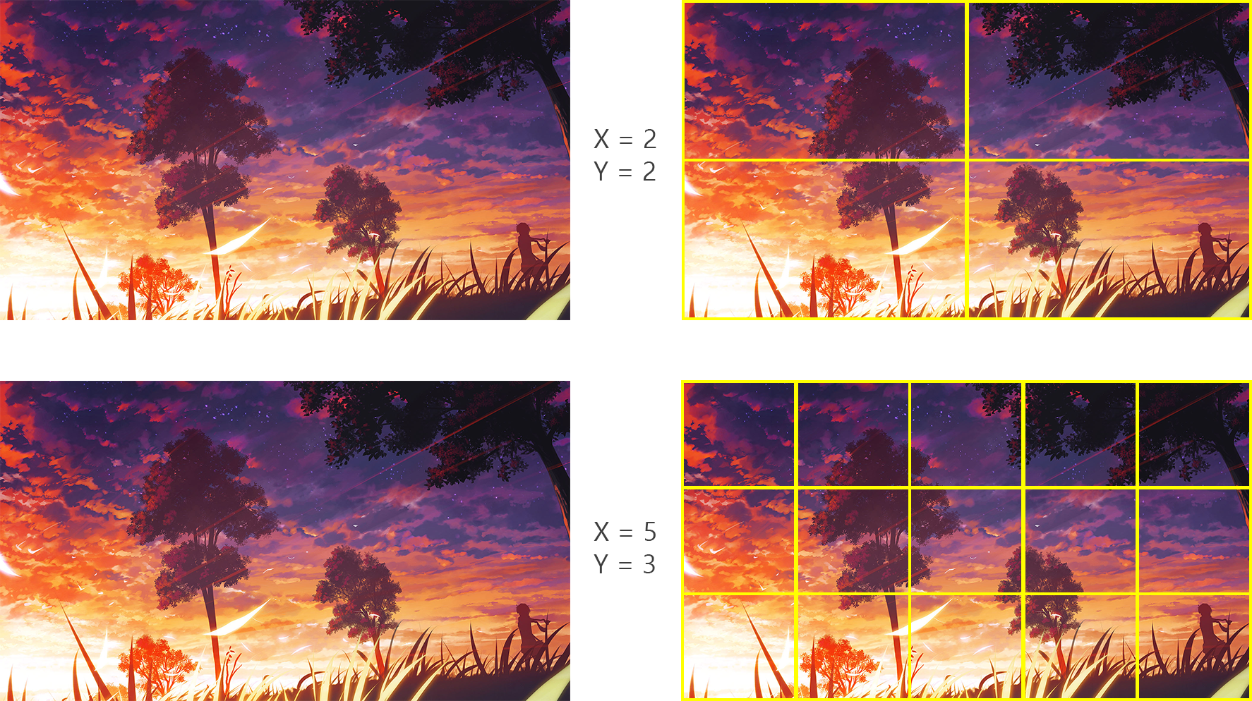

**C18: Animation (Normal)**

Create the same animation that is presented in the video. A Hello world wording appears with line animation.

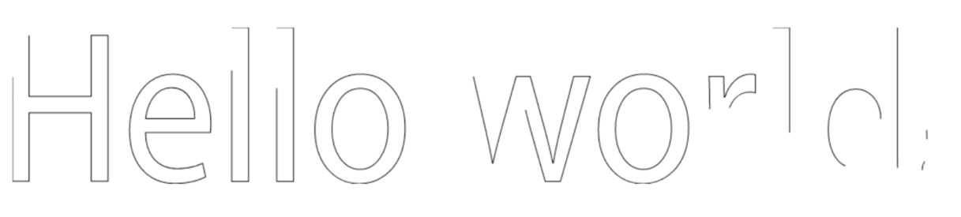

## C19: Chart from data (Difficult)

You should create a Chart Drawing with provided data(death-rate-by-source-from-air-pollution.csv). There are Death rates from air pollution of all countries from 1990 to 2017 in the data. Chart shoud calculate all data of all countries.

In the page, there shoud be a Chart which shows rates of 3 data (Ozone pollution, Householdpollution from solidfuels, Outdoor particulatematter) from 1990 to 2017. See the examples below, but you can create your own style.

For this test, you can only use HTML, CSS and JavaScript (including jQuery or JS Framework).

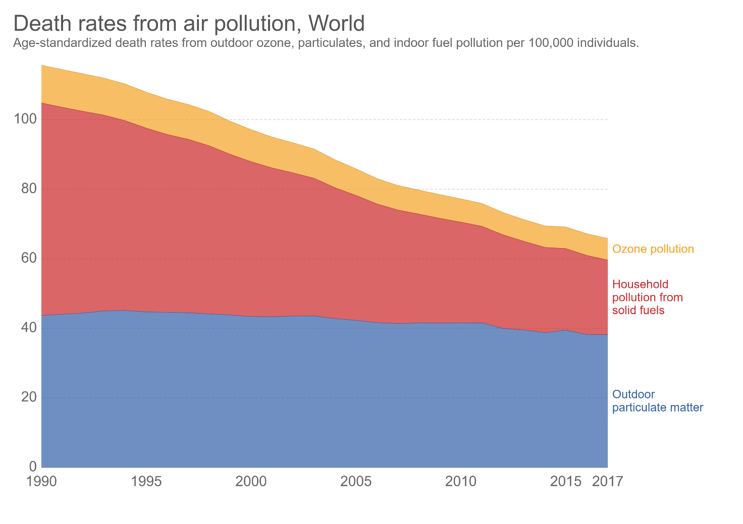

## C24: Array Integers (Easy)

Given an array that contains integers, rearrange on crescent order only in the positives integers, keeping the negatives on the same position (consoles the new array rearranged);

## C25: Following cursor (Easy)

You have a div on the screen. make the div follows and be centered of accord a cursor position in the window;

## C26: Circles (Normal)

Create a page, that contains 5 circles. Each circle contains one of the following texts: Home, About, Contact, Map, Privacy, the texts are centered both horizontally, and vertically. Position of the circles are random on the page, but no overlap allowed. The whole area of the circle must be visible. The page has a 20px padding.. Size of the circles is random between 300-400px on each load too.

The color of the circles are: #1F2041, #4B3F72, #417B5A, #D0CEBA, #E9D2C0.

## C27: Linear gradient (Normal)

On the center of the screen there is a 300px sized square. By default it has a red to blue linear gradient background. On the left and right of the square there are 1-1 input fields where you can change the starting, and ending color of the linear gradient, by writing in the HEX value of the color. Over the inputs there are 10 randomized color buttons (10px*10px) on each side. If you click one of the randomized colors, it’s color is inserted in the input. Whenever any input is changed, and is a valid hex, that side’s linear gradient color changes on the square.

# Part D: Back-End Development

## D1: PHP Calendar (Difficult)

1. You can create index.php using index.html

2. When you open the index.php, in the top area of calendar, current month and current year should be shown and today's date should be highlited like index.html

3. If you click the left arrow button the previous month calendar should be shown.

4. If you click the right arrow button the next month calendar should be shown.

## D2: Plugin works (Easy)

Make a plugin that when activated, insert a new menu item on admin, and when accessed, shows a Title: "Plugin works!".

## D3: PHP Array (Easy)

Given the code with some PHP arrays in media files, please implement a PHP function that compare the given two arrays and return a new array that contains the common elements from both given arrays.

## D4: PHP Verification captcha (Difficult)

Please use PHP to produce verification code image (captcha), which must comply the following rules (please see the provided images):

a. It randomly generates four characters, consisting of English Alphabet (A-Z) or digit numbers (0-9).

b. The four characters must be slightly rotated.

c. The four characters must not be located at the same row.

d. The image contains at least 3 random lines.

e. At least 3 mixed noise points.

## D5: Watermark (Easy)

Put a watermark (png file) on the image provided. The watermark should be in the lower right corner.

## D6: Predominant colors (Easy)

Identify the 3 predominant colors in the provided image and show them.

## D8: File manager (Normal)

Create a file manager to view the file system, delete files and folders, edit files and save them.

## D10 Image Cropper (Normal)

Create an application which can upload an image and crop to save and download.

* Upload an image on the server
* Show the uploaded image on the screen.
* Draw a dotted rectangle in the image area(only dotted rectangle is needed, no path selectors).
* Click [crop] button to crop the selected rectangle area and cropped image saved with prefix “crop_”.
* After crop complete the [crop] button should be changed to [download] button.
* When click [download] button, user can download cropped image.

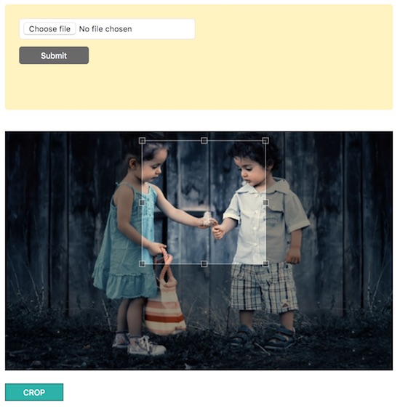

## D11: A Pagination Code (Nromal)

After reading data.json, the data in the current page must be shown..

5 data must be shown in one page.

5 page links to move to another page must be shown in one page

Create buttons to move 5 pages at once, previous and next.

Page link of current page must be located in the center

Take a look at the provided screen shots and data.json.

You can only use HTML & CSS & PHP, but for reading json data and the pagination code must use only PHP. You can use bootstrap and JavaScript is not allowed.

Screen shots:



## D12: XML2JSON Converter (Difficult)

Create a simple xml to json convertor using pure PHP(See the example.xml).

Screen shot:

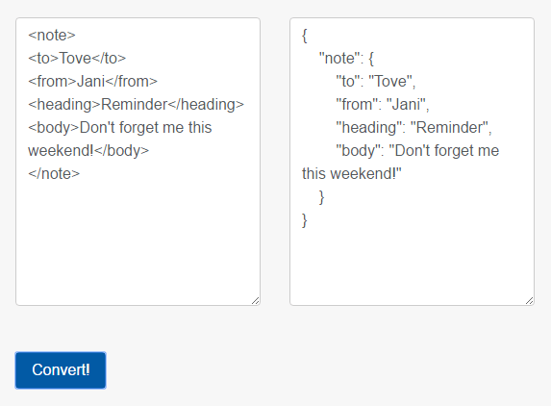

## D13: Remove duplicates (Easy)

Given an array, remove the duplicate values, and show the new array;

# Part E: Content Management Systems

## E1: Animated Social Button Plugin (Normal)

Create social buttons plugin for Wordpress using Fontawesome icons and add hover effects for the buttons.

When the plugin activated, social buttons must be shown in the footer area.

There should be 4 social buttons and the icon fonts are below.

facebook - <i class="fab fa-facebook-f"></i>

pinterest - <i class="fab fa-pinterest"></i>

twitter - <i class="fab fa-twitter"></i>

thumblr - <i class="fab fa-tumblr"></i>

The color of hover effects are below.

facebook - #3d5998

pinterest - #e50122

twitter - #54acec

thumblr - #314258

The effects should be same with thie example video but you can change the duration time of the hover effects.

You can only use HTML and CSS, no JS(including Libries and Framewors) are allowed.

Screen Shots(See the video.mp4 in folder named “2”)

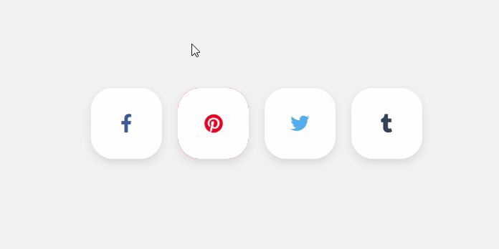

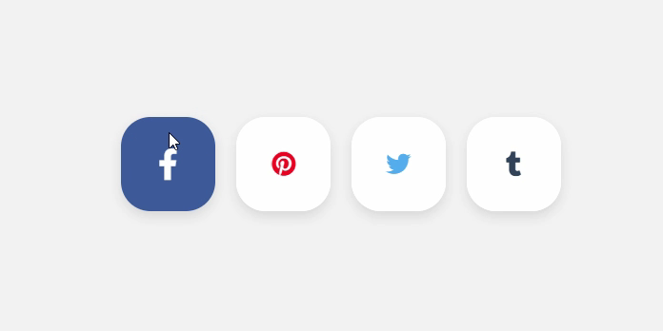

## E2: Dropdown menu plugin (Difficult)

Create a Plugin that shows the menu. It must be able to be used in the theme through shortcode.

Admin can add/delete menus. When mouse is over one of the menu items, delete icon or button should be shown so that admin can delete the menu. The menus should not be static.

**Menus shown in the CMS main page**  
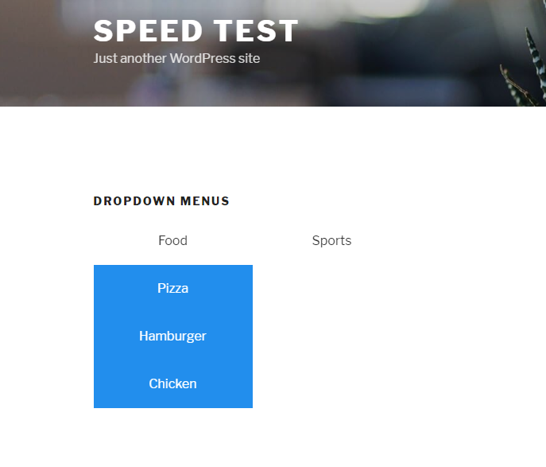

## E3: CountDown Kazan WorldSkills plugin (Normal)

Create a plugin that tells the time left until 22d of August.

When the plugin is activated, widget is created.

If widget is added in sidebar, remaining time must be shown.

The date should not a static data.

## E4: Plugin works (Easy)

- Make a plugin that when activated, insert a new menu item on admin, and when accessed, shows a Title: "Plugin works!";

## E5: Gallery Upload (Normal)

- Make a plugin that make possible upload multiple media in the gallery of wordpress with a new menu item called "Gallery upload";

## E6: Custom Area (Easy)

- Make a new widget area called "Custom area", that needs to be on the footer on default theme;

## E7: Widget (Easy)

- Make a widget that list of title of all pages created, with their permalinks;

## E8: Technical works (Normal)

Create a plug-in that displays the button “Enable technical work” / “Disable technical work” on the Dashboard, depending on the state of which the client part will display either the Technical work screen, if “technical work is enabled”, or the site itself.

## E9: Color theme (Normal)

Create a plugin that changes the color on the site depending on whether the dark or light theme is enabled on the computer.

## E10: Installing Wordpress (Easy)

Now a client needs a wordpress blog to go up and live very quickly. They don’t care about the layout so default theme should work. But they want to have a “Steelblue” top bar and “Light Cyan” background color on their blog. Please install a new wordpress website with the following requirement:

* Title: Handy Cafe
* Sub-title: A cafe that you never forget.
* Top color bar on all page: 5 px steel blue
* Background color on all page: light cyan
* Categories: products, closing time, events
* There are menus on home page that links to posts listing of the mentioned categories.

# Instructions to the Competitor

You do not need to implement all the tasks. There will be instruction on C1 to clarify which tasks are selected to be implemented.

# Marking Scheme

|  |  |  |  |  |
| --- | --- | --- | --- | --- |
| Section | CRiterion | judgement marks | measurement marks | total |
| A1 | Design | 0 | 2 | 2 |
| A2 | Layout | 0 | 2 | 2 |
| A3 | Front-end | 0 | 2 | 2 |
| A4 | Back-end | 0 | 2 | 2 |
| A5 | CMS | 0 | 2 | 2 |